1. Introduction
Our vision is that every child born today in Lancashire, and every citizen, will grow up and live in a community and an environment that enables them to live healthier for longer, have a job when they leave education and achieve their full potential throughout life. We want to improve outcomes for all children and young people in Lancashire, but we know that there are many groups of children who are particularly vulnerable and will find it more difficult to secure these positive outcomes, including children in care or on the edge of care.

Where families go through difficult times, we will do everything we can to provide support at the earliest opportunity to prevent crisis interventions and minimise the number of children and young people in care. We want to work ‘with’ families and not to do ‘to them’. We want families to take ownership of the issues they are facing and to help them build the skills, understanding and confidence to overcome them.

Where it is not possible for children to live at home with their families, we will ensure that they are provided with the best start in life. Key to achieving this is ensuring that we find them the right placement in the right place at the right time to best meet their needs.

Lancashire County Council has a statutory duty to ensure that there is a range of placements sufficient to meet the needs of the children and young people in the care of the local authority; and to make arrangements to promote co-operation with relevant partners to improve the well-being of children in the local area.

This document should be read in conjunction with:
- Lancashire Children and Young People's Plan
- Lancashire Joint Strategic Needs Assessment
- Lancashire Children Looked After (CLA) Residential Strategy

The strategy sets out how Lancashire County Council intends to meet its Sufficiency Duty for the children we look after, improve the quality and choice of placements, ensure value for money and minimise the likelihood of suitable placements not being available locally.

2. Analysis of our Children Looked After
Please see Appendix 1 for an overview of related general population statistics for Lancashire.

Numbers of Children in Care

The number of looked after children in England has continued to rise, increasing steadily over the last eight years. There were 70,440 looked after children at 31 March 2016, an increase of 1% compared to 31 March 2015 and an increase of 5% compared to 2012.

There were 1,665 looked after children in Lancashire at 31st March 2016, an increase of 5% compared to 31st March 2015 and an increase of 26% compared to 2012. Numbers have continued to rise since March 2016, increasing to 1,848 in March 2017 and 1,891 in July 2017 – an overall increase of 43% when compared to the 1325 CLA in Lancashire in March 2012.

Rate of Children in Care

At 31st March 2016, the rate of CLA in England (per 10,000 population) was 60, which has remained consistent since March 2012, when the rate was 59. In contrast, Lancashire's rate has changed considerably, from below the national average in March 2012 (54) to significantly above the national average (68) in March 2016.

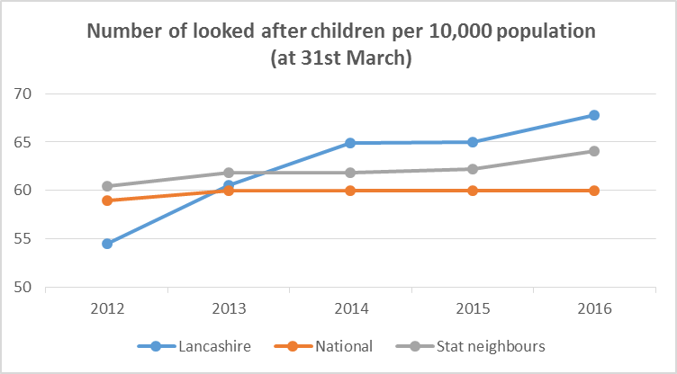

Lancashire's rate has continued to grow since March 2016 and reached 74.9 in March 2017 and 76.7 in July 2017. If this rate was to be brought in line with the national average (at 31st March 2016) of 60, then Lancashire would need to have 1,481 CLA.

However, bringing figures in line with the national rate is considered to be very challenging when compared to the average rate of our statistical neighbours (64.1) and the average rate of CLA across the North West region (82). Lancashire's CLA rate of 68 in March 2016 was the 4th lowest rate in the North West.

Local Authority Area | No. of CLA (31/3/12) | No. of CLA (31/3/16) | % change in CLA (2012 to 2016) | Rate of CLA per 10,000 population (31/3/16) | Rate change between 2012 and 2016
Stockport | 295 | 295 | 0% | 47 | -2
Cheshire East | 440 | 385 | -13% | 51 | -8
England | 67,070 | 70,440 | +5% | 60 | +1
Trafford | 275 | 330 | +20% | 61 | +8
Lancashire | 1,325 | 1,665 | +26% | 68 | +14
Cheshire West and Chester | 365 | 465 | +27% | 71 | +15
Cumbria | 595 | 660 | +11% | 71 | +15
Oldham | 325 | 415 | +28% | 71 | +14
Bury | 325 | 305 | -6% | 72 | -6
Wigan | 480 | 485 | +1% | 72 | +1
Warrington | 235 | 345 | +47% | 78 | +24
North West | 11,380 | 12,550 | +10% | 82 | +6
Halton | 125 | 240 | +92% | 85 | +41
Bolton | 515 | 560 | +9% | 85 | +5
Sefton | 400 | 465 | +16% | 87 | +14
Tameside | 390 | 425 | +9% | 87 | +7
Knowsley | 255 | 290 | +14% | 89 | +11
Blackburn with Darwen | 360 | 350 | -3% | 91 | -2
Rochdale | 450 | 485 | +8% | 95 | +8
Wirral | 670 | 670 | 0% | 99 | +0
Salford | 555 | 555 | 0% | 103 | -6
Manchester | 1,305 | 1,235 | -5% | 105 | -15
St Helens | 335 | 410 | +22% | 113 | +21
Liverpool | 930 | 1,040 | +12% | 115 | +10
Blackpool | 435 | 470 | +8% | 164 | +14

Given the above and the fact that Lancashire's rate is continuing to rise, a more realistic target of reducing the rate per 10,000 by 10, from 76.7 to 66.7 (1646 CLA) has been set to be achieved over the course of this strategy. However, our aim remains to prevent entry into care where this is safe and appropriate and therefore we will strive to exceed this target if possible.

Gender

At 31 March 2016, 56% of children looked after in England were male, 44% female and these proportions have varied little over recent years. The gender distribution in Lancashire has also remained fairly consistent over the past five years with 53-55% of the CLA population being male:

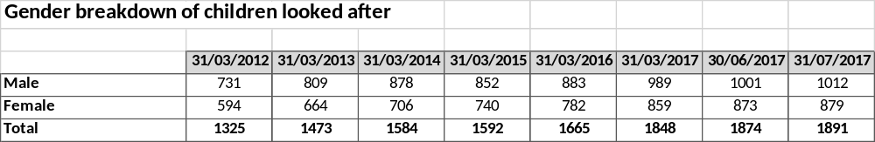

Age

Nationally, the age profile has continued to change over the last four years, with a steady increase in the number and proportion of older children. 62% of children looked after were aged 10 years and over in 2016 compared with 56% in 2012. There has been a reduction in the number and proportion of children aged 1-4 years to 13% in 2016, from 18% in 2012.

The age profile has also changed over time in Lancashire. In line with the national trend, there has been a reduction in the 1-4 age cohort, from 21% in 2012 to 17% in 2017. However, the percentage of CLA aged 11-17 has remained relatively consistent at almost half (48% in 2012 and 49% in 2017) and there has been an increase in CLA aged 5-10, from 24% at March 2012 to 29% in July 2017:

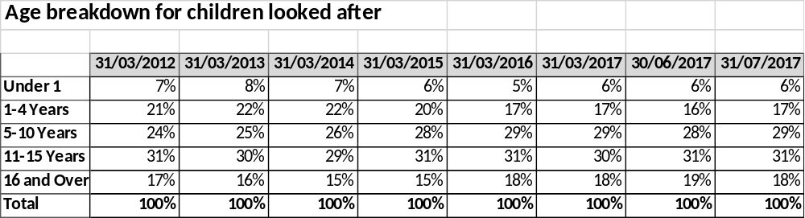

Ethnicity

The ethnicity of Lancashire's CLA continues to be predominately White British, representing 86.5% of the total CLA population at July 2017, compared to 90.0% in March 2012.

Starting to be looked after

Lancashire is experiencing growth in the number of children starting to be looked after. In the year to 31st July 2017 there was a 23% increase compared to the year ending 31st March 2015. The most prevalent age band for growth has been 5-10 year olds, with 42% increase whereas under 1 has seen an increase of just 6%. Whilst national data is not available for this period, the most recent published data indicates a 2% increase in England from 2015 to 2016, compared to 9% in Lancashire.

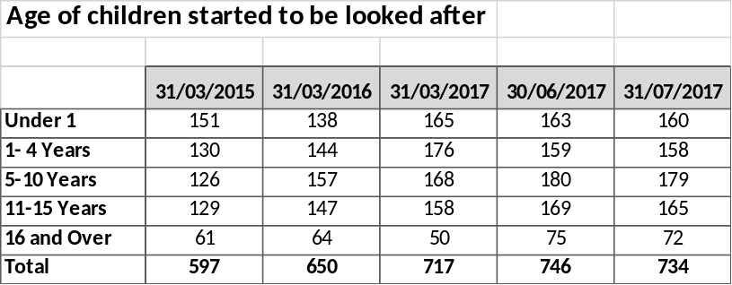

Ceased to be looked after

Since April 2015 on average 575 children ceased to be looked after each year. The table below shows that the 12-month year-to-date trend declines to 31st March 2017, with a slight upward trend being experienced into 2017/18. The most prevalent age groups for young people ceasing to be looked after continues to be aged 16-17 (33%, an increase from 29% in 2014/15), and children aged 1-4 (30%, a reduction from 34% in 2014/15).

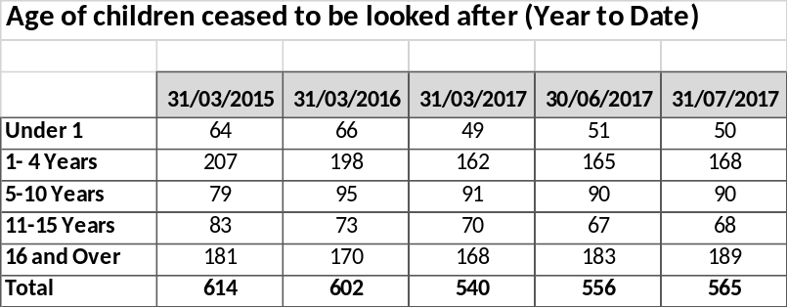

During 2016/17, the most prevalent reasons for discharge were: Special Guardianship (21.7%); Return home to parents, no order, planned or unplanned (19.1%); and Adoption (13.0%).

Section 20 Agreements

As of 31st July 2017, 10% (195) of our CLA were accommodated voluntarily under Section 20 of the Children's Act 1989. 80% (156) of these were aged 14 – 17 years (with 56% (110) of the cohort aged 16-17 years). 57% (111) of placements for Section 20 CLA were with agency providers and 25% were placed in in-house provision. 7% (8) of Section 20 CLA aged 16-17 were placed in the block purchased supported accommodation provision.

Analysis of CLA accommodated under Section 20 Agreement (as of 31/7/17)
Type of Provision | Number of S20 CLA |  | Age Range | Number of S20 CLA
Agency Residential | 46 |  | 0-5 years | 14
Agency Fostering | 44 |  | 0-5 years | 14
In-House Fostering | 33 |  | 6-10 years | 11
Agency Semi-Independent | 31 |  | 6-10 years | 11
In-House Residential | 16 |  | 11-13 years | 14
Residential School | 13 |  | 11-13 years | 14
Block Purchased Supported Accommodation | 8 |  | 14-15 years | 46
Other (Hospital; Short Break; Reg 38.6; placed for adoption) | 4 |  | 16-17 years | 110

Reducing the number of our CLA accommodated under a Section 20 Agreement is a key factor in achieving an overall reduction in our numbers of CLA over the next three years. We aim to do this by ensuring that:
- a risk sensible approach is embedded across the Children's Social Care workforce;
- families remain together wherever possible through the provision of an effective prevention, early help and outreach/ edge of care offer;
- no Section 20 Agreements are accepted, where there are no child protection concerns, without families first accessing the prevention, early help and outreach/ edge of care offer;
- the Section 20 Charging Policy is consistently and rigorously enforced.

3. CLA Placement Analysis and Current Provision
Breakdown of placement type for Lancashire CLA (March 2012- July 2017)

 | 31/3/12 | 31/3/13 | 31/3/14 | 31/3/15 | 31/3/16 | 31/3/17 | 31/6/17 | 31/7/17
Placed with parents or other person with parental responsibility | 127 | 138 | 170 | 219 | 266 | 326 | 343 | 346
Foster placement with relative or friend | 84 | 101 | 81 | 117 | 112 | 174 | 147 | 155
Placement with other foster carer | 861 | 973 | 1022 | 967 | 995 | 1034 | 1049 | 1029
Children's homes | 107 | 108 | 119 | 121 | 138 | 99 | 114 | 120
Residential accommodation not subject to 'Children's Homes Regulations' | 0 | 0 | 2 | 1 | 4 | 6 | 4 | 4
Residential care homes | 17 | 29 | 35 | 27 | 38 | 71 | 73 | 75
All residential schools, except where dual-registered as a school and children's home | 12 | 7 | 4 | 1 | 1 | 1 | 7 | 7
NHS/ Health Trust or other establishment providing medical or nursing care | 1 | 4 | 2 | 3 | 3 | 3 | 3 | 3
Family Centre or Mother and Baby Unit | 1 | 0 | 1 | 3 | 5 | 8 | 13 | 11
Young Offender Institution or prison | 3 | 4 | 4 | 7 | 5 | 7 | 4 | 4
Secure Unit | 4 | 3 | 1 | 2 | 3 | 6 | 5 | 4
Independent living | 45 | 35 | 41 | 33 | 45 | 68 | 69 | 76
Placed for adoption | 62 | 71 | 102 | 91 | 50 | 39 | 39 | 48
Other | 1 | 0 | 0 | 0 | 0 | 6 | 4 | 9
Total | 1325 | 1473 | 1584 | 1592 | 1665 | 1848 | 1874 | 1891

Placed with Parents or other person with parental responsibility

Lancashire has experienced a significant increase in the number of CLA placed with parents or other person with parental responsibility, with the proportion doubling from 9.6% in March 2012 to 18.3% in July 2017. This is significantly higher than the proportion of placements nationally (5.4% as of 31/3/16) and higher than the North West proportion in March 2016 (12.5%). Lancashire's proportion of placements (15.9%) was the 4th highest in the North West in March 2016, behind Sefton (21.5%), Bury (16.4%) and Salford (16.2%). Our neighbouring unitary authorities had higher than the national but lower than the regional percentage of such placements (Blackburn with Darwen 11.4% and Blackpool 9.6%).

Over the course of this strategy, we aspire to more than halve the number of placements with parents or other person with parental responsibility, back to the level they were in March 2014 (170). This would equate to 10.3% of CLA placements and would bring us in line with our neighbouring unitary authorities. We will do this through more effective and robust care planning, with contingency planning routed in a risk sensible model. We will also support our staff to work more confidently within the court arena and with legal colleagues.

Foster Care

Nationally, the number of children in foster care has continued to rise, with 74% cared for in foster placements as of 31/3/16. Whilst the number has increased, as a proportion of all looked after children, it has remained stable.

The majority of Lancashire CLA placements are made into foster care. Lancashire however has a lower proportion placed with foster carers than the national average, with this cohort representing 66.4% as at 31st March 2016 and lower than the proportion placed in Lancashire in March 2012 (71.3%). The proportion of fostering placements continued to fall to 62.6% in July 2017, despite an actual increase in the number of foster placements (1107 in March '16 and 1184 in July '17). Part of the reduction since March 2012 can be explained by the significant increase in the proportion of placements with parents or other person with parental responsibility, which has skewed the fostering figures, as demonstrated in the table below:

Local Authority CLA Statistics as of 31/3/16
Local Authority Area | No. of CLA | No. and % of home placements |  | No. and % of fostering placements |  | % of fostering placements (excl placed with parents)
England | 70,440 | 3,810 | 5.4% | 51,850 | 73.6% | 77.8%
Blackpool | 470 | 45 | 9.6% | 335 | 71.3% | 78.8%
North West | 12,550 | 1,570 | 12.5% | 8,840 | 70.4% | 80.5%
Blackburn with Darwen | 350 | 40 | 11.4% | 240 | 68.6% | 77.4%
Salford | 555 | 90 | 16.2% | 375 | 67.6% | 80.6%
Lancashire | 1,665 | 265 | 15.9% | 1,105* | 66.4% | 78.9%
Bury | 305 | 50 | 16.3% | 200 | 65.6% | 78.4%
Sefton | 465 | 100 | 21.5% | 295 | 63.4% | 80.8%
* National dataset rounds figures to nearest 5

When placements with parents or other person with parental responsibility are removed from the dataset, the proportion of fostering placements in March 2016 in Lancashire were the same level as in March 2012 (78.9%) and were similar to national figures. For Lancashire to achieve the North West average (excluding placements with parents), of 80.5% by 2020, the current level of fostering placements provided (1184 in July '17) will need to be maintained and slightly increased (to 1188) alongside a reduction in our overall numbers of CLA to 1646.

There has been a shift in the proportion of foster placements made with our in-house foster carers compared to independent foster agency (IFA) commissioned placements. In July 2017, 505 (45%) of placements with foster carers had been made through IFAs, compared to 437 (40%) in January 2014. This reflects the challenges that local authorities throughout the country are facing in recruiting carers. We are committed to further increasing the number and usage of in-house fostering placements and the overall proportion of our in-house to agency fostering placements.

There is currently a lack of capacity within the in-house fostering service to provide suitable placements for larger sibling groups, parent and child placements and more complex children and young people. More streamlined recruitment processes and a more targeted marketing strategy have been implemented, alongside proactively working with fostering families to encourage existing and new carers to consider looking after a wider range of children and young people.

IFA placements are commissioned through a local Framework Agreement, which is currently out for re-tender, with new arrangements due to begin in April 2018. The current arrangement includes 25 providers and works well, with 95% of placements made through the framework.

Between 20th February 2017 (commencement of the new Access to Resources Team - ART) and 31st July 2017 there were 412 referrals for a fostering placement for 467 individual looked after children:

Type of fostering referral | % and No. of referrals received | % and No. of each referral type classed as 'hard to find'
Task Centred foster placement (up to 26 weeks) | 50% (208) | 17% (36)
Permanent foster placement | 26% (108) | 18% (19)
Respite foster placement | 13% (52) | 8% (4)
Mother and baby foster placement | 11% (44) | 11% (5)
TOTAL | 100% (412) | 16% (64)

Age Range of CYP on fostering referrals | % and No. of CYP | % and No. of CYP in each age group classed as 'hard to find'
0-5 years | 34% (159) | 5% (8)
6-10 years | 20% (95) | 16% (15)
11-13 years | 19% (89) | 25% (22)
14-17 years | 27% (124) | 19% (23)
TOTAL | 100% (467 CYP) | 16% (68 CYP)

66% of the 'hard to find' foster placements were for young people aged 11-17 years, the majority of which were referrals for task centred foster placements.

Since the establishment of ART, the increased capacity and improved placement finding processes has enabled 6 'hard to find' fostering placements to be sourced, either preventing a residential placement in the first place or enabling a step down from residential into fostering. We will continue to prioritise the sourcing of such placements, with a target of sourcing 12 'hard to find' fostering placements per year.

Despite improved placement finding processes, it continues to be a challenge to find suitable fostering placements for our more complex young people, who require more specialist support. Between February and July 2017, there were 8 children (aged between 9 and 14) with a plan for fostering but who had to be placed in residential provision due to not being able to source a suitable fostering placement. Fostering searches are continuing for these young people. A further 7 young people have been identified, who were placed in residential provision before February 2017, where a fostering placement is deemed to be more appropriate.

A key priority for Lancashire is to further develop 'step down into fostering' provision in collaboration with IFAs, and consider the development of internal provision, to better enable children and young people with a plan for fostering to be supported to move out of residential and into suitable provision. From July 2018, we aim to develop 10 new 'step down into fostering' placements per annum.

In summary, by 2020, we aim to increase the proportion of our fostering placements (excluding placed with parents) to become in line with the North West average of 80.5%. We will do this by:
- sourcing 12 'hard to find' fostering placements per annum, through improved placement finding processes;
- sourcing 10 'step down into fostering placements per annum, by developing such provision in collaboration with our independent fostering agencies;
- working collaboratively with IFAs to better shape the market to meet need.

Residential Care

Residential care continues to be a valuable service to provide stable support and provision to the CLA population.

There has been a rising trend in the number of Lancashire children and young people placed in children's homes. At 31st July 2017 there were 180 placements (40 in-house and 140 agency placements) compared to 125 at 31st January 2014, an increase of 44%. However whilst the number has increased, children's home placements as a proportion of all placements has increased less dramatically, from 8.5% to 9.5%.

Throughout the course of this strategy, we aim to reduce the number of young people placed in children's homes back to the levels they were at as of February 2014 (136 placements) or 8.3% of all CLA placements.

The in-house residential offer in Lancashire currently includes 10 children's homes (7 x 6 bed mainstream homes; 2 x 3 bed complex needs homes; and 1 x 6 bed Short Term Assessment Unit). This internal provision is to be further expanded during 2017/18 to include a highly complex 1-2 bed home; an Adolescent Support Unit; and a Short Term Crisis Unit.

During 2016/17 the in-house residential service operated at 75% capacity, and under-occupancy has continued into 2017/18. Challenges including the inability to source external placements for our most complex young people, matching issues and Ofsted restrictions have impacted on the effective usage of our in-house provision. The establishment of ART is starting to reduce these challenges (i.e. there has not been a need to place very complex young people in an emergency in mainstream internal provision due to alternatives being able to be sourced). Increasing in-house occupancy levels and reducing the usage of external residential provision is a key priority for Lancashire over the next two years. We aim to increase the number of in-house children's home placements from the current 40 to 54 and return to a ratio of 60:40 agency: in-house placements (rather than the current ratio of 78:22).

Externally, residential care is commissioned through a local Flexible Agreement, which has been in place since August 2016. 40 residential providers and all their homes inside or within 20 miles of LCC boundaries are included on the Flexible Agreement. Lancashire is also named on the new Regional Residential Framework, due to commence in 2018, which will be used to source placements not able to be found through the Lancashire Flexible Agreement. As of 31st July 2017, the average cost of an external residential placement had risen by 45% since 2014.

Lancashire Residential Flexible Agreement Tier | Number of Homes | Minimum Number of Beds*
1 | 45 | 127
2 | 88 | 325
3 | 62 | 244
4 | 4 | 20
Not Tiered (awaiting registration/ inspection) | 12 | 48
Total | 211 | 764
* Please note that some homes on the agreement are 6+ bed homes. All assumed in the figures above as 6 bed

Between 20th February 2017 (commencement of ART) and 31st July 2017 there has been 170 referrals for a residential placement for a looked after child: 151 for a children's home placement; 16 for a placement in a family assessment centre; and 3 for a residential school placement. 15% of these placement searches (26) were classed as 'hard to find', with the majority (92%) being requests for children's home placements.

Key observations on 'hard to find' residential placements:
- Two thirds were for young people aged 15 and 16 years;
- 63% of the hard to find residential placements were for males;
- 70% of these referrals referenced missing from home;
- 45% referenced aggressive/ violent behaviours;
- 30% referenced child sexual exploitation;
- 20% referenced mental health issues;
- 20% referenced criminal behaviours;
- At least a quarter of referrals specifically requested a 1 to 3 bed complex home.

Whilst improved placement finding processes has enabled the sourcing of all these hard to find placements, the sourcing of local residential placements for our most complex young people is very challenging and time consuming (29% of hard to find placements were placed outside of LCC boundaries).

Alongside considering the development of more internal complex children's homes provision, a key priority for Lancashire is to work better with the local residential care market to efficiently source more local provision to meet the needs of our most complex young people.

16+ Leaving Care

A range of provision is commissioned for care leavers, 16+ looked after young people and young people who are homeless. This includes some young people who are subject to the Staying Put policy and as such remain living within existing foster care arrangements and young people who are supported to move into semi-independent unregulated accommodation provided as part of block purchased supported accommodation provision or through the use of the North West 16+ Leaving Care Dynamic Purchasing System (DPS). Some leaving care provision is currently ‘spot purchased’ outside of these arrangements.

To support the monitoring of quality in this unregulated sector, accommodation providers commissioned through the regional DPS have all achieved the minimum standard assessment co-ordinated by Placements North West. The block contract service providers are required to achieve level B of the Supporting People Quality Assessment Framework. Providers are expected to support young people to become independent and focus on the skills to enable a successful move on.

Breakdown of Providers of Block Purchased Supported Accommodation (for CYP aged 16-21)
Type of Provision | Number of Providers | Number of Beds
Crisis | 3 | 16
Supported accommodation | 12 | 233
Dispersed supported accommodation (with visiting support) | 1 | 85
Supported lodgings | 3 | 36
TOTAL |  | 370
* The above figures include specialist provision for teenage parents

Breakdown of Providers on North West 16+ Leaving Care DPS (Zone 3 – North)

Type of Provision | Number of Providers
Semi Independent/ Group Living | 27
Accommodation with Floating Support | 24
Floating Support | 26

Breakdown of Care Leavers by Category (as of 31/7/17)

Category of Care Leaver | Number of CYP
Eligible - a young person aged 16 and 17 who has been looked after for at least 13 weeks since the age of 14 and who is still being looked after | 320
Relevant - a young person aged 16 and 17 who had been looked after for at least 13 weeks since the age of 14 and who has left care | 10
Former Relevant – a young person between the ages of 18-21 (or 24 if in education or training) who was previously 'eligible' or 'relevant' | 436
Qualifying - a young person under 21 (or 24 if in education or training) who stops being looked after, accommodated or privately fostered after the age of 16 | 10
Total | 776

Breakdown of Eligible Care Leavers by Placement Type (as of 31/7/17)

Placement Type | Number of CYP
Placed with Parent | 21
Reg 38.6 | 1
Placed with Family Member | 1
In House Fostering | 57
Agency Fostering | 85
In House Residential | 14
Agency Residential | 61
Residential School | 6
In-House Short Breaks Provision | 1
Secure Welfare | 2
Hospital | 2
Remand | 4
Block Purchased Supported Accommodation Provision | 3
Agency Leaving Care Provision | 61
Independent Living | 1
Total | 320

Of significance is the 19% of eligible care leavers who are placed in agency residential provision. Blackpool has recently introduced a strategy of reviewing all young people aged 16 and over placed in externally commissioned residential provision. Social workers are asked to complete an Assessment of Need and develop a step down for a move to independence. Progress is tracked through weekly panels and by a newly appointed Placement Co-ordinator, who prompts social workers, supports placement finding, builds relationships with providers and facilitates moves into independence. To date, it has been calculated that this approach has produced savings of c. £650,000 per annum. A similar approach will be adopted in Lancashire, via the revised Resource Panels and expanded Access to Resources Team and will contribute towards the target of reducing the number of children's homes placements back to 2014 levels.

A key priority related to leaving care is to increase the usage of the block purchased supported accommodation provision for 16+ looked after young people, 16-17 year old homeless young people and 18-21 year olds known to Children's Social Care. In March 2016, 16-17 year old young people utilised 32% (119) of the block purchased beds.

From October 2017, we will change the way we allocate our block purchased placements, giving 16-17 year old young people the highest priority, followed by 18-21 year olds who are known to Children's Social Care. By November 2018, we will seek to utilise 45% (165 beds) for young people aged 16-17 years and 23% (83 beds) for 18-21 year olds known to Children's Social Care.

There is an increasing prevalence of high level complex needs in our looked after population. As these young people reach the age of 16 and therefore become care leavers we need to be planning on how those needs can be met in an appropriate leaving care setting.

It is a priority to work with leaving care providers to increase the range of local 16+ accommodation, including for our most complex young people, to ensure that it is fit for purpose, achieving positive outcomes and preparing young people for independent living.

Managing Remands in the Youth Justice System

Reducing the use of Custody for young people is a national performance indicator for Youth Offending Teams (YOTs). In 2011 the Youth Justice Board (YJB) highlighted Lancashire as having high numbers of young people being remanded to the secure estate from the Courts (this excluded Blackpool and Blackburn with Darwen). The number of young people remanded was considerably above the national average. A national advisor from the YJB was appointed to support Lancashire YOT (LYOT) in exploring the reasons leading to the high number of secure remands and devising a strategy to address the issue.

The outcome of this joint piece of work led to implementing an improved remand management strategy, including: a monitoring system for all bail and remand outcomes; revising LYOT's Bail Supervision work; parents or carers contacted prior to court and encouraged to attend the hearing; LYOT staff attending court; interviewing the young person to ascertain suitable bail addresses; assessing safeguarding needs and/or presenting risk. Community alternatives to remands to the secure estate are then offered to the Court and potential addresses are verified by the Police and Children's Social Care, as to their suitability for the young person.

LYOT has in place coherent bail and remand procedures and this has been further improved with the implementation of AssetPlus, a nationally revised and improved assessment process. LYOT has also implemented improvements to LYOT Court services and processes which includes preparation for case management at Court. LYOT has a positive relationship with the Courts who are confident in considering bail proposals provided by LYOT.

LYOT and LCC Foster Care service jointly promoted, developed and monitor foster care placements to receive overnight transfers from the police for young people refused police bail. LYOT has also commissioned an Extended Youth Justice Service to provide support and contact during the evenings and at weekends, including those who have been made subject to bail conditions.

The result of this work is since 2011 there has been a steady decrease in the numbers of young people in Lancashire being remanded to the secure estate (Local Authority Secure Children's Home, Secure Training Centre or Young Offenders Institution) or community based local authority accommodation (see following table). The Legal Aid, Sentencing and Punishment of Offenders Act 2012, further supported the reduction of preventable remands for young people with the introduction of the Youth Detention Accommodation (YDA). A young person subject to a YDA becomes a looked after child and the local authority meets the cost of YDAs.

LYOT has in place a Custody and Remand review panel which ensures cases are effectively managed and if all alternatives to the remand have been considered. To support the reduction of breach procedures (where a young person is not complying and is returned to Court for consideration of resentencing), LYOT has in place a non-compliance panel were managers, practitioners, parents/carers and other significant individuals seek to re-engage young people with their intervention plans.

In LYOT's 'Service Continuous Improvement Plan' 2017-18 there is a focus on improving resettlement of young people leaving custody.

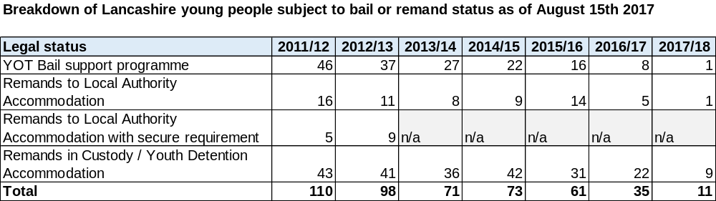

Secure Welfare Placements

Between 1/8/16 to 31/7/17 10 secure welfare placements were made for 8 individual children and young people. Placement duration ranged from 49 nights to 340 nights, with an average of 200 bed nights per placement and costs in excess of £1m.

An audit is being undertaken on the young people who went into secure welfare accommodation to identify what could have been done better to prevent and support more effective step down. Learning will be taken from this audit, an action plan will be developed and the findings will be used to inform the development of further complex residential provision in Lancashire.

4. Commissioning Priorities
An overall Council priority, working with our partners, is to reduce the numbers of our children in care. Our aim over the next three years is to reduce our levels to 1646 CLA, a rate of 66.7 per 10,000 of the CYP population.

Prevention

Key to reducing our overall CLA numbers will be reducing the number of children who start to become looked after (particularly those who do so voluntarily as part of a Section 20 Agreement), by providing the means for families to become more resilient and stay together where it is safe and in the child's best interests to do so.

We will do this by:
- Embedding a risk sensible approach across the Children's Social Care workforce;
- Providing an effective prevention and early help offer through our Wellbeing, Prevention and Early Help Service;
- Developing respite provision for children and young people on the edge of care and expanding our outreach provision, in line with best practice in Blackburn with Darwen;
- Ensuring that all new Section 20 Agreements (where there are not child protection concerns) are only accepted after families have accessed the above offers;
- Rigorously enforcing our Section 20 Charging Policy.

Consideration will also be given to developing a Lancashire 'PAUSE' model, building on the learning from the DfE Innovation Programme. PAUSE is designed to address the problems of women who have experienced, or are at risk of, repeated pregnancies that result in children needed to be removed from their care. The intense programme of therapeutic, practical and behavioural support aims to break this cycle and give women the opportunity to reflect, tackle destructive patterns of behaviour and to develop new skills and responses to help them create a more positive future. Women who are selected for the programme are required to take a long acting reversible contraception during the intervention, thereby creating a space to PAUSE, reflect, learn and aspire.

Placement Finding and Effective Market Engagement

The establishment of the new Access to Resources Team (ART) by bringing together existing placement finding, contract monitoring and commissioning resources has resulted in significantly improved placement finding processes and intelligence on demand and gaps in provision.

We intend to build on this success by expanding ART to further enhance relationships with providers, enable effective contract management and work in collaboration with providers to shape the market to better meet need.

There continues to be challenges in relation to the quality of referrals received, effective use of notice periods to ensure that the right placement can be found first time and planning for permanence. We will address this by delivering training to social workers on placement finding and permanence.

We will also work with providers to develop a process for identifying and better supporting vulnerable placements to prevent unnecessary placement breakdowns. We will do this by providing guidance and training for social workers on what constitutes a vulnerable placement and identifying triggers for potential placement breakdown. We will develop placement stability meetings, including provider and partner involvement, to closely monitor vulnerable placements and put in place support to enable placements to succeed.

Placements with Parents or other person with parental responsibility

We will halve the number of placements with parents or other person with parental responsibility, and return them to the March 2014 levels (170) by:
- Ensuring effective and robust care planning, with contingency planning routed in a risk sensible model;
- Supporting our staff to work more confidently within the court arena and with legal colleagues;
- Continuing to review all of our children who are placed at home with parents and seek revocation of orders where appropriate;
- Ensuring that where appropriate these families are supported by our wellbeing, prevention and early help services as they step down from high level intervention.

Foster Care

The overarching priority for the in-house service is to increase the number and range of in-house fostering placements provided. This will be addressed by:
- Implementing a more targeted marketing strategy to address gaps in provision, including larger sibling groups, more complex children and young people and parent and child placements;
- Maximising capacity of existing foster carers by working with fostering families to encourage a wider range of placements;
- Maximising the use of LIFT (Lancashire's Interventions for Families Team), including effective promotion with Children's Social Care, to provide support to existing carers, prevent adoption breakdowns and support reunification.

The current Independent Fostering Framework on the whole is working well and providing good local capacity. Improved placement finding processes are supporting more hard to find agency fostering placements to be secured. However, there continues to be challenges in relation to the provision of suitable fostering placements for our more complex children and young people.

We intend to address this by developing new commissioning arrangements to facilitate collaboration with a small number of IFAs to develop effective step down into fostering provision, and consider the development of in-house complex fostering placements.

Overall, by 2020, we aim to increase the proportion of our fostering placements (excluding placed with parents) to become in line with the North West average of 80.5%. We will do this by:
- sourcing 12 'hard to find' fostering placements per annum, through improved placement finding processes;
- sourcing 10 'step down into fostering' placements per annum, by developing provision in collaboration with our independent fostering agencies and considering the development of internal 'step down into fostering' placements;
- working collaboratively with IFAs to better shape the market to meet need.

Residential Care

The overarching priority is to reduce the numbers of young people in residential provision and reduce the overall placements budget. We will reduce the number of residential placements to 136 by March 2019, with an improved ratio of 60:40 (agency: in-house placements). We will do this by:

- scrutinising the appropriateness of residential placements;
- developing effective step down provision to support appropriate young people to move into foster care and semi-independent provision;
- ensuring effective use is made of our in-house children's homes, increasing placements provided from 40 to 54.

Sourcing appropriate residential placements for our most complex children in care will continue to be a key priority. We will do this by:

- developing a highly complex 1-2 bed in-house children's home alongside the existing 2 x 3 bed complex homes;
- development of an in-house crisis unit to de-escalate/ prevent placement breakdowns and support the sourcing of the right placement to best meet need;
- exploring block purchasing complex beds in collaboration with other local authorities and /or consider the further development of internal complex beds;
- auditing cases of young people in secure welfare provision in order to identify ways in which this could have been prevented or stepped down more appropriately, including through the development of local complex provision.

16+ Leaving Care

We will prioritise the usage of our block purchased supported accommodation provision for 16+ looked after young people, 16-17 year old homeless young people and 18-21 year old young people who are known to Children's Social Care. We will do this by:

- Varying existing block contract arrangements to prioritise young people to whom LCC has a statutory responsibility, with targets of 45% (165 beds) for 16-17 year olds and 23% (83 beds) for 18-21 year old young people who are known to Children's Social Care;
- Improving placement finding processes through the extended Access to Resources Team and the updated Joint County Council and District Housing Protocol;
- Working collaboratively with Providers to improve outcomes for young people, including enabling young people to become independent and successfully move on;
- Monitoring the usage of block contract accommodation from October 2017, with a view to informing future commissioning intentions when the current contracts expire in 2019;
- Reviewing the need for and availability of emergency provision.

Sourcing effective local leaving care provision for our most complex young people is also a priority. We will work collaboratively with the leaving care market to increase the range of local accommodation for this cohort of young people.

We will work collaboratively with external fostering providers to further develop 'Staying Put' arrangements. We will also work closely with residential providers and district councils to develop 'Staying Close' arrangements.

5. Key Performance Indicators
The following Key Performance Indicators will be monitored and reported quarterly:

Key Performance Indicator | Current Levels | Target | Impact
Reduction in numbers of CLA | 1891 (July '17) | 1646 by 2020 | 245
Reduction in rate of CLA | 76.7 (July '17) | 66.7 by 2020 | 10.0
Reduction in the Number of 10-17 Year Olds Starting to be Looked After who are Accommodated Under Section 20 | 140 in 2015/16 | 104 by March 2019 | 36
Reduction in number of placements with parents or other person with parental responsibility | 346 (July '17) | 170 by 2020 | 176
Increase the proportion of foster placements (excluding placements with parents) | 76.6% (July '17) | 80.5% by March 2020 | 3.9%
Number of 'Hard to Find' fostering placements sourced by ART per annum |  | 12 from April 2018 | 12
Number of Step Down into Fostering Placements sourced per annum |  | 10 from July 2018 | 10
Reduction in the Number of CLA in Residential Children's Homes | 180 (July '17) | 136 by March 2019 | 44
Reduction in the Proportion of CLA in Residential Children's Homes compared to placements overall | 9.5% (July '17) | 8.3% by March 2020 | 1.2%
Increased numbers of in-house Children's Homes placements | 40 (July '17) | 54 by March 2019 | 14
Reduction in proportion of agency children's home to in-house children's home placements | 78:22  (July' 17) | 60:40 by March 2019 | 18 agency  18 in-house
Increase the usage of block purchased supported accommodation provision | 32% (119 beds) used by 16-17 year old CYP (March 2016) | 45% (165 beds) for 16-17 year olds and 23% (83 beds) for 18-21 year olds (known to Children's Social Care) by November '18 | 46 beds for 16-17 year olds

Please note that the achievement of targets above assumes a steady state in respect of overall demand levels.
Appendix 1: Relevant General Lancashire Population Statistics
Location

Lancashire County Council is located in the North West of England and is the fourth largest council in the UK. Lancashire County Council contains 12 district councils and has two neighbouring unitary councils: Blackpool and Blackburn with Darwen. The council covers an area of 2,903 sq km.

Demographics

The current population of 0-17 year olds in Lancashire is estimated to be 246,792, 20.6% of the total Lancashire population. The following chart shows the breakdown of this age group broken by single-year-of-age and gender.

Population of 0-17 year olds in Lancashire, 2016 (Source: Office for National Statistics, 2016)
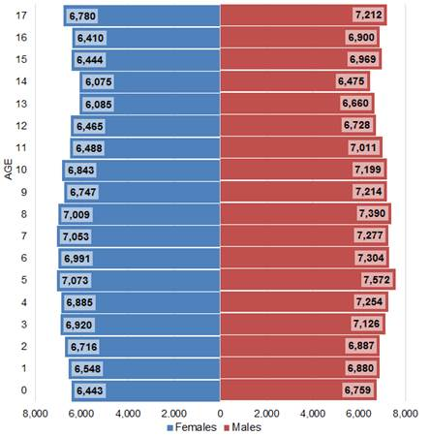
The most recent population projections show that there is a slight decline in the percentage of 0-17 year olds in Lancashire over the period from 2014 to 2039 from 20.7% to 19.5%. The chart below shows the projections broken by age group.

Population projection 2014-2039 (Source: Office for National Statistics, 2016)
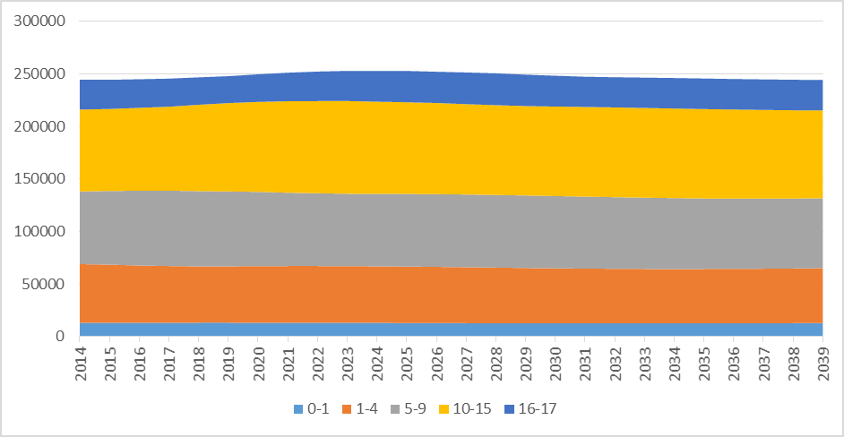

Social and Economic Context

From a family context, Lancashire has seen a small but notable shift in the nature of family structures. Between the 2001 and 2011 censuses the number of "traditional" married/cohabiting families with dependent children has reduced from 21.6% of all households to 18.9%, whilst the number of lone-parent households with dependent children has increased from 6.7% to 7.1%. Lone-parent households range from 5.5% in Ribble Valley to 8.9% of all households in Hyndburn. (Office for National Statistics, 2001 and 2011)

The socio-economic-status of families correlates with poor outcomes and in this context a number of Lancashire's children grow up in poor performing (statistically speaking) areas. The English Indices of Deprivation is a useful baseline for comparing authorities as it combines a range of deprivation factors under a single measure. Using this index Lancashire County Council is ranked 87, out of 152 upper tier local authorities, which puts the county in the middle ground (3rd quintile, 57%), where 1 is the most deprived. This has not changed significantly from the 2010 Indices of Multiple Deprivation. (Department for Communities and Local Government, 2015)

Other Relevant Socio-Economic Measures and Comparisons

Measure | Lancashire performance compared to national | Significant district comparisons
Working age residents reliant on benefits* | In line with national average of 11.8% | Significantly higher in Burnley (17.3%) and Hyndburn (16.1%).
Median gross weekly earnings for residents (all employees)** | 8% lower than UK average | Ribble Valley is the only district above the UK average. In contrast, Rossendale was tenth lowest, more than £100 below the UK
Workplace population with no formal qualification*** | 10.9% in Lancashire; 10.2% in England and Wales | Highest districts are Pendle (14.2%) and Hyndburn (13.7%)
Workforce population with a level 4 qualification (degree or above)*** | 30.5% in Lancashire; 34.9% in England and Wales | Lowest level 4 percentages are Pendle (24.5%) and Wyre (25.3%)
* DWP, 2016 ** Office for National Statistics, 2016 *** Office for National Statistics, 2011

From a health perspective, the health of people in Lancashire is generally worse than the England average and there are marked inequalities both between Lancashire and the national average, and within the county itself.

Measure | Lancashire performance compared to national | Significant district comparisons
Female life expectancy at birth* | 82.1 years in Lancashire, significantly lower than England (83.1 years) | Statistically similar to England in 4 districts: Fylde, Ribble Valley, South Ribble and West Lancashire. Significantly lower than England in other 8 districts
Male life expectancy at birth* | 78.5 years in Lancashire, significantly lower than England (79.5 years) | Significantly higher than England in Ribble Valley. Chorley, Fylde, South Ribble, West Lancashire and Wyre are similar. Remaining 6 districts are lower.
* Office for National Statistics, 2015

Poverty and Deprivation

Lancashire is a county of contrasts; there are high levels of deprivation and relative affluence both between and within districts. There are four districts in the 10% most deprived authorities in England alongside districts in the top 30% least deprived.

Burnley is the most deprived district within the county council area, with a rank of average rank of 17, where 1 is the most deprived and 326 is the least. Hyndburn (28) and Pendle (42) are also in the top 20% most deprived authority areas in the country. Ribble Valley (290) is the only district within the top 20% least deprived authority areas in the country.

Between 2010 and 2015, the Indices of Deprivation results indicate a continuing trend of growing disparities between the most and least deprived areas of the county.
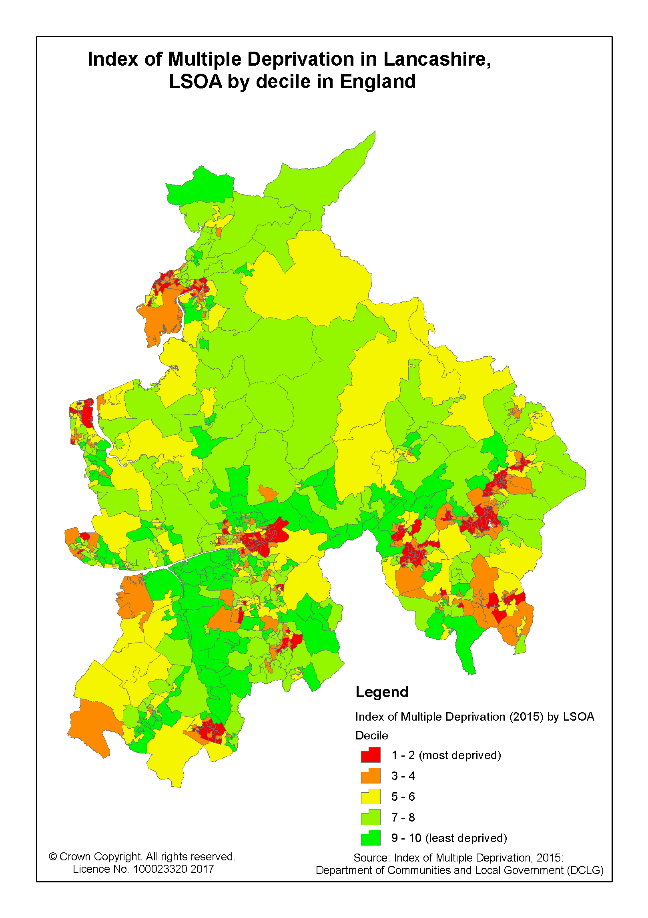
Poverty is also a significant factor in parts of Lancashire. Estimates for 2014/15 show that in Burnley 32% of children live in poverty (the proportion below 60 per cent of median income after housing costs) and in Hyndburn it is 30%. In contrast it is 11% in Ribble Valley. This compares to a UK figure of 29%. (Centre for Research in Social Policy, 2015)

Education and Children's Outcomes

In terms of academic achievement, there are strong differences between disadvantaged pupils (i.e. children looked after for at least one day or adopted from care or those eligible for free school meals in the last 6 years) and non-disadvantaged pupils.
Measure | Performance
Proportion of disadvantaged pupils attaining expected levels at KS2 in Reading, Writing and Maths | 38% compared to 61% for non-disadvantaged pupils (23% lower)
Average GCSE attainment 8 score for disadvantaged pupils | 38.9 compared to 53.1 for non-disadvantaged pupils (14.2+ points lower)

Approximately 5.0% of Lancashire's young people (16-18 year olds) are not in employment, education, or training. Within the county's 12 districts, the proportion of 16 to 18 year-olds who are NEET ranges from 1.9% in Ribble Valley to 7.3% in Preston.

Appendix 2: Stakeholder Views
Views of Children and Young People

Lancashire County Council is committed to children being empowered; participating in the services they receive and the communities in which they live.

Children and Young People across Lancashire have been involved in a number of participation opportunities in relation to fostering and residential services. The information received over a number of years has been rich and diverse and when analysed can be split into 4 key areas; communication; relationships; participation and emotional health and wellbeing. In summary, CYP have told us that:

Communication...
- Information should be tailored to CYP wants and likes, in other words, communication tailored to the audience, including guides, welcome packs, hopes and wishes boxes, confidentiality policies, etc.
- CYP are listened to through regular feedback on issues which have been raised. Reiterating that identified changes have been made due to what has been said to the carers/ agency.

Relationships…
- Placements are close to home/ friends/ college/ school/ local amenities.
- CYP know who their key worker and / or social worker is.
- Carers/ Staff receive suitable and specific training that supports individual CYP needs.
- Matching processes are in place that promote stability and avoid placement disruption.
- Placements support a sense of local community.
- Placements support contact with birth family where appropriate
- There is high levels of staff retention in order to support CYP relationship building.
Participation…
- CYP are engaged in the process of their care and know how providers are going to work with them and in what way(s).
- Services adopt strategies that ensure the voice of the child is heard, such as including and involving young people on interview panels and training.
- CYP are involved in the matching process.
- Providers and carers encourage CYP to engage with community groups.
- Carers/ Staff and agencies engage with LINX (Lancashire's Children in Care Council).
- Participation is embedded into everything and that policies are adhered to stringently.
Emotional Health and Wellbeing…
- Each child or young person is placed based on their own emotional needs.
- Carers/ Staff are fair, supportive, friendly and caring and make young people feel valued.
- Additional support is available to support emotional health and wellbeing.
- Age appropriate provision for independence is provided which helps CYP to make positive decisions about their own actions and future.

Provider Views

Colleagues from 19 Fostering and 24 Residential provider organisations attended provider events in June 2017 to explore how LCC and Providers can work better together to address gaps in provision and achieve the best possible outcomes for our children in care.

Providers were asked to give their views on 2 key challenges: 1. How do we address gaps in provision?; 2. How do we better support placements to succeed?

Barriers and actions relating to improved placement finding, social care practice, staffing and Ofsted were identified. These included:

- Some referrals continue to be of poor quality
- Further information required on wrap around support and strategies to address MFH and CSE
- High levels of emergency referrals
- More provider input required into referrals and care planning
- More effective use of notice periods required to ensure sufficient time to find the right placement
- Better communication required with social workers prior to and on receiving offers
- Feedback required for providers on offers received
- Better care planning and communication on plans for permanence
- There is an under-supply of smaller homes and demand for short term beds is huge
- Collaborative work is required to develop effective step down into fostering provision
- Regular communication of what Lancashire needs and more collaboration to enable more effective planning to address gaps in provision
- Better mechanisms and greater joint working required to identify and support vulnerable placements
- Need to better plan for young people coming out of secure provision
- Better relationships are required with health, particularly in relation to mental health services
- Ofsted issues re. matching/ meeting need/ risk of taking CYP with risk of MFH, CSE, not in education preventing providers offering placements for most complex CYP

Feedback from Providers to the events was overwhelmingly positive. Comments received included honesty of presentations and discussions, effectiveness of the solution focused discussion groups and commitment to working collaboratively together to best meet need.

